Scope:

let declares a variable that is block-scoped (curly brackets {} of the amazingFunction).

Curly brackets of while loop, for loop ,function and if statement is a block.

Hence, console.log(myName) can only be accessed inside amazing function, not outside.

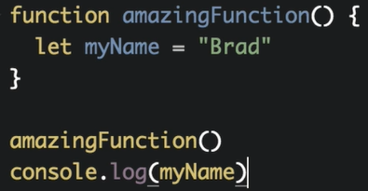

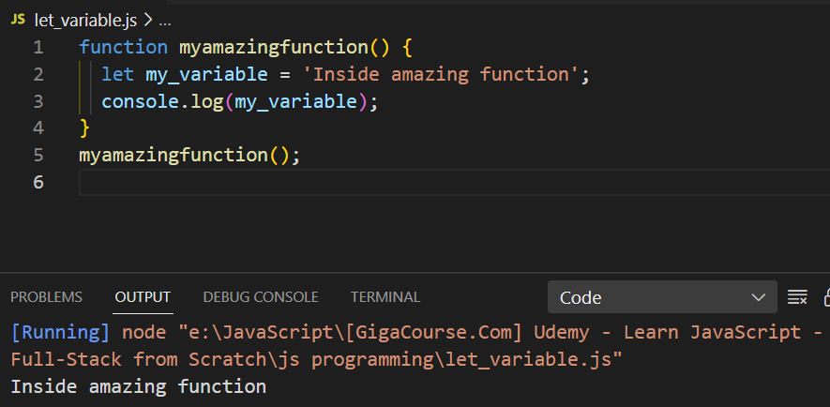

Attempting to access the my_variable outside the myamazingfunction will give error.

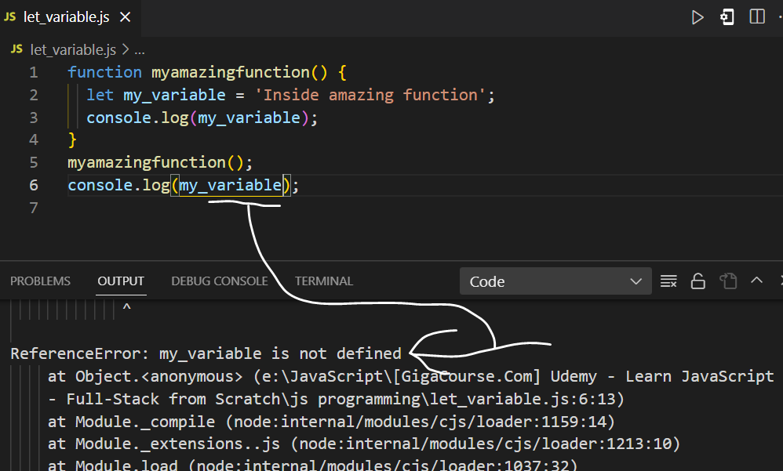

**Globally declared let variable:**

Globally declared let variable can be accessed an where inside (inside function, inside if, inside for loop, inside while loop ) the program.

The function call occurs first then last console.log is executed

**Scope is like a one-way street:**

Code can reach outward to access the variable, code cannot reach inward to access the variable.

Scope begins inward and moves outward.

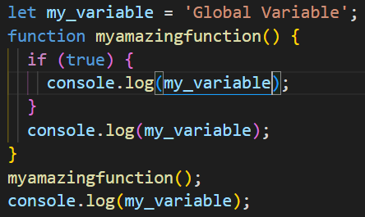

When if code in if statement is executed, JavaScript sees if there is my_variable within current scope (with in the curly brackets {} of if or block).

Block is the curly brackets of if, function, for loop and while loop.

If my_variable is not found with in the current scope then, JavaScript will look one level up (with in the curly brackets of myamazingfunction), even still my_variable is not found within one level up then JavaScript will move one level up (outside the curly brackets of myamazingfunction) and upon finding the my_variable JavScript will print it on console.

**Each time we declare variable using a let key word brand new variable is created:**

// Following my_variable is  new global variable is accessible anywhere

let my_variable = 'Global Variable';

function myamazingfunction () {

  // Following my_variable is a new variable and is only accessible anywhere inside myamazingfunction

  let my_variable = 'I am a brand-new variable inside myamazingfunction';

  console.log(my_variable);

  if (true) {

    // Following my_variable is a new variable and is accessible anywhere inside the myamazingfunction

    let my_variable = 'I am a brand-new variable inside if';

    console.log(my_variable);

  }

}

**Output:**

**Mutating global variable:**

// Followong my_variable is  new global variable is accessible anywhere

let my_variable = 'Global Variable';

function myamazingfunction() {

  // Updating and mutating global variable inside myamazingfunction

  // Accessing my_variable global variable

  my_variable = 'I am a mutated varible inside myamazingfunction';

  console.log(my_variable);

  if (true) {

    // Updating and mutating global variable inside if

    my_variable = 'I am a mutated  variable inside if';

    console.log(my_variable);

  }

}

myamazingfunction();

console.log(my_variable);

Inside if statement ,JavaScript will look whether variable my_variable exists inside the current block(curly brackets of if) of if statements. If the variable my_variable does not exist in the current local scope (curly brackets of if ) , then JavaScript will look one level up(inside myamazing function) for the variable my_variable. If still variable my_variable does not exist inside myamazing function then JavaScript will continue to look one level up until variable my_variable is found and variable my_variable is updated where it accessed and set to some particular value.

Similarly:

function myamazingfunction() {

  let my_variable = 'Global Variable';

  // Updating and mutating global variable inside myamazingfunction

  // Accessing my_variable global variable

  my_variable = 'I am a mutated varible inside myamazingfunction';

  console.log(my_variable);

  if (true) {

    // Updating and mutating global variable inside if

    my_variable = 'I am a mutated  variable inside if';

    console.log(my_variable);

  }

}

myamazingfunction();

**Output:**

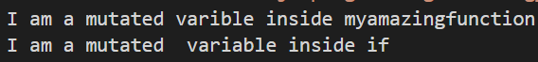

JavaScript will start looking for the variable my_variable from the if statement and keep looking one level up until variable my_variable is found inside myamazing function, and variable my_variable is updated where (inside if statement and myamazing function) it is set to some value.

**Using Var:**

When var variable declared globally, it can be accessed throughout the entire program. When declared locally to a function, it can only be accessed within that function.

Var uses function scope , hence variable declared with var keyword is accessible anywhere inside the function.

**Locally declared var variable:**

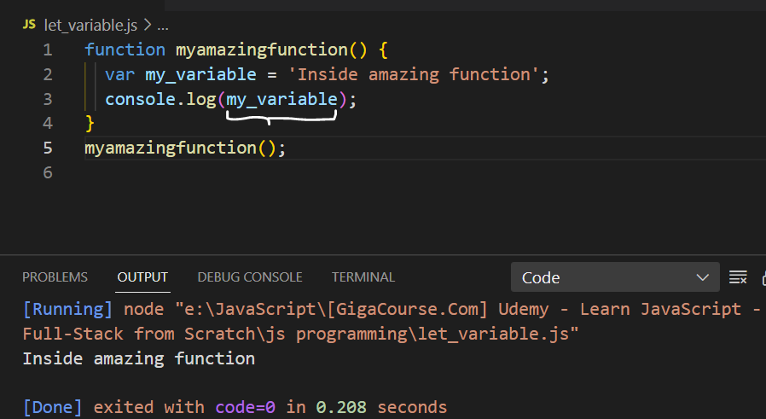

**Attempting to access the locally created var variable outside a function will give error**

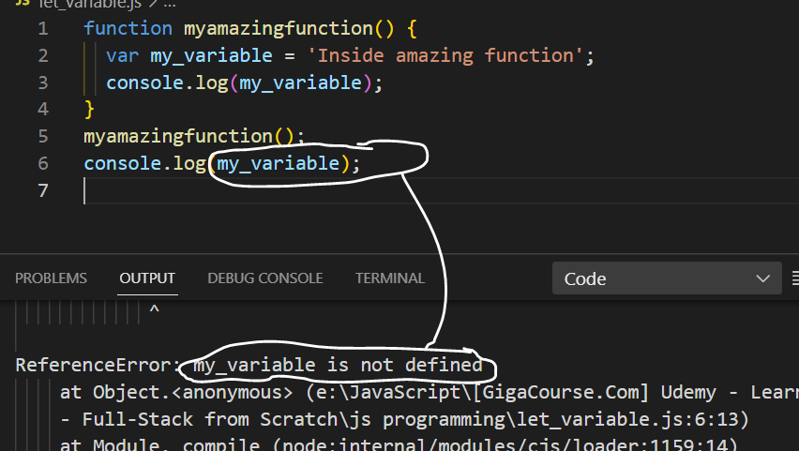

**Since var uses function scope not the block scope so if variable created using var key word inside if (if must be inside function) can be accessed:**

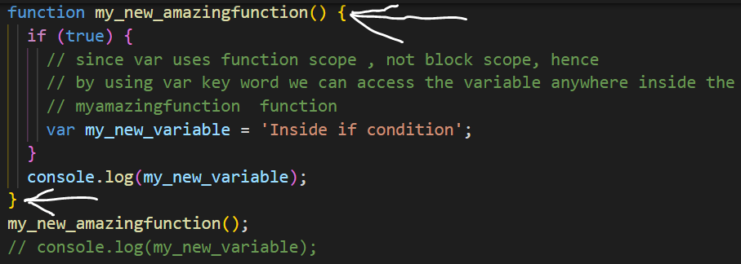

**Output**



**Whereas if we had used let key word then, my_new_variable would not be accessible inside my_new_amazingfunction, it would only be accessible inside if statement.**



